I give the chat gpt with instruction what is he need to do for test survey with giving example a sheet to understand it properly .Here is the result that I found from him my prompt and ss is below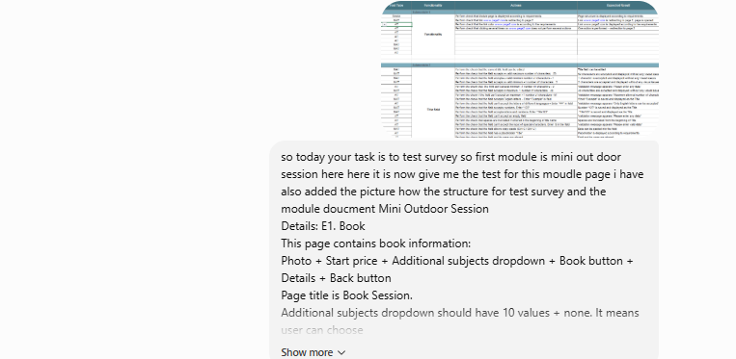
“So today your task is to test survey so first module is Mini Outdoor Session. Here it is now; give me the test for this module page i have also added the picture of the structure for test survey and the module document Mini Outdoor Session
As a reply he first give me this for book page

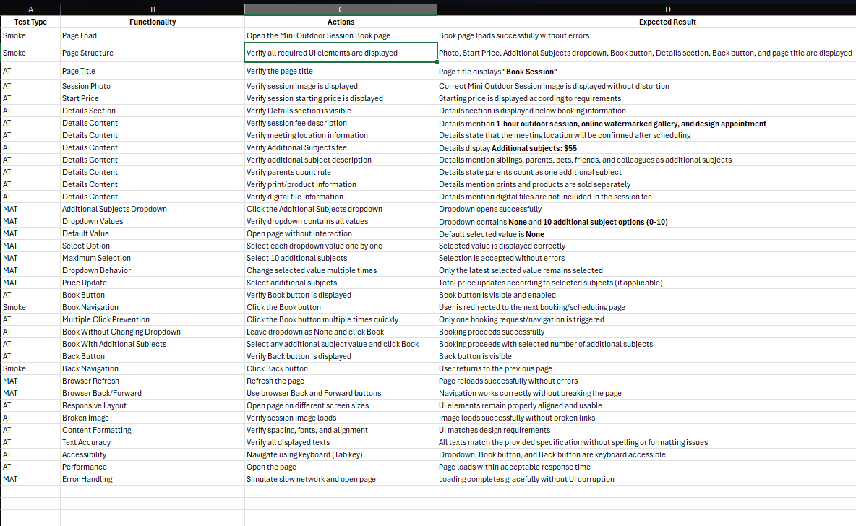
So first of all he cannot structured those coloum and module properly.So, not bothering about it I just focus on action and the expected result and also test type.
What I have that ChatGPT's version doesn't
- Module/Submodule structure : my sheet has a Module column "Mini Outdoor Session" and a Submodule: Book row. ChatGPT's is flat no module hierarchy at all.
- Header and Footer testing that I have done.ChatGPT's sheet has zero header/footer test cases.
- Specific, verifiable expected results : I write things like "$350 USD" and "Book Session" and name exact redirect destinations.ChatGPT's equivalent rows say vague things like "according to requirements" or "next booking/scheduling page".But I mention which page will direct to which page.But in this case I don’t miss effective test
ChatGPT's version has that mine doesn't
- he split it into 7 separate test cases .He also follow as mine like page title structure ,session photo etc.But the main thing is he did 8 test case for details section.For each details like from description to price also some garbage test done.
- More rigorous dropdown testing :he adds edge cases: selecting the max (10), rapidly changing selections to confirm only the latest sticks, and a price-update check tied to selection.Mine dropdown coverage looks solid but doesn't explicitly test the max-selection edge case or rapid reselection behavior which I missed in my test case.This is more important.
- Book button : double-click/multiple-request prevention, booking with dropdown left at default vs. changed. Where he trying to check whether previous selected data remains after page switching.In my cause I don’t check that kind action like multiple request prevention.Also forget the page swiching check action
- Non-functional test categories :here he also did some non functional test which did not wanted from him.

After that I went forward to the next module which is book information.
I give hime prompt to do the rest of task for booking information it created 54 cases any they are
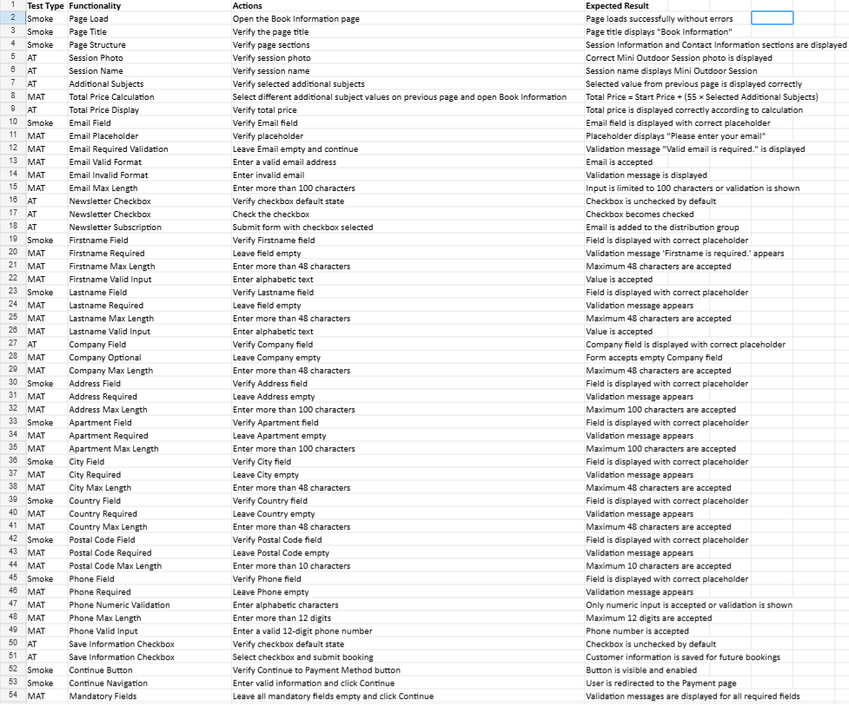

Here ,I have found that Ai more likely cannot properly select what type of test it is base on action and result.But here Ai created only 54 test case by using all the data for book information page .On the other hand I created 227 test for book information module.
What I have that ChatGPT's version doesn't
- First one I used around 11 action to test additional subject value that make changes prooperly but in here chat gpt doesn’t do they just check “Select different additional subject values on previous page and open Book Information”.I tested for all the value.
- chat gpt only test valid ,invalid, required validation,place holder ,max length for all of the input fields, like (e.g. first name,last name, email).if the field is required, then they test required validation.On the other hand I have created action like for positon , field alignment,besides that I also check with boundary value length for all the field like less than minimun, minimum, maximum, gretter than maximum.Than base on field like name cannot contain special charact , also creat number check,also script injection ,

Here ,I have found that Ai more likely cannot properly select what type of test it is base on action and result.But here Ai created only 54 test case by using all the data for book information page .On the other hand I created 227 test for book information module.
What I have that ChatGPT's version doesn't
- First one I used around 11 action to test additional subject value that make changes prooperly but in here chat gpt doesn’t do they just check “Select different additional subject values on previous page and open Book Information”.I tested for all the value.
- chat gpt only test valid ,invalid, required validation,place holder ,max length for all of the input fields, like (e.g. first name,last name, email).if the field is required, then they test required validation.On the other hand I have created action like for positon , field alignment,besides that I also check with boundary value length for all the field like less than minimun, minimum, maximum, gretter than maximum.Than base on field like name cannot contain special charact , also creat number check,also script injection ,

